Chapter 3 Variance and the F Ratio

1. Completing the analysis
   1. Summary table – ANOVA calculations

|  |  |  |  |  |  |
| --- | --- | --- | --- | --- | --- |
| Source | Term | SS | DF | MS | F |
| A (between) | [A] | [A]-[T] | a – 1 | SSa/dfa | MSa/MSs/a |
| S/A (within) | [Y] | [Y]-[A] | a(n-1) | SSs/a/dfs/a |  |
| Total | [T] | [Y]-[T] | an-1 |  |  |

* + 1. 1st –
    2. 2nd –
    3. 3rd – df = degrees of freedom
    4. 4th – mean squares –
  1. Confidence intervals for treatment means
     1. Definition
     2. Formula
     3. Estimating the Sm – standard error of the mean
  2. F-ratio –

1. Evaluating the F-ratio
   1. Null hypothesis significance testing
   2. Sampling distribution
   3. Monte Carlos

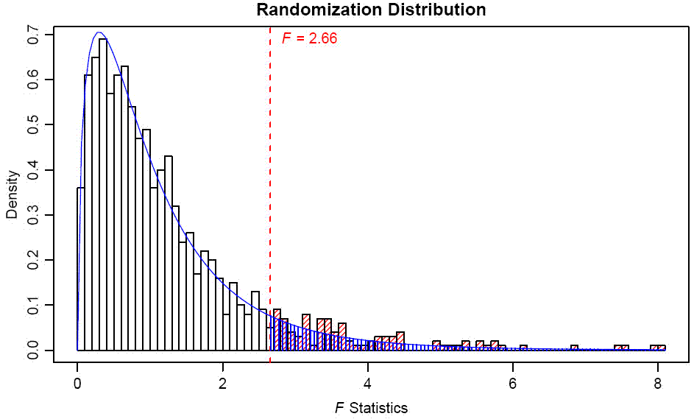

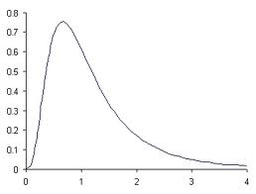

* 1. The F-table.
  2. The f-distribution when the null is false
     1. Central F distribution
     2. Noncentral F distribution
     3. 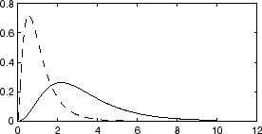
  3. Testing the Null Hypothesis
     1. Null hypothesis
     2. Alternative hypothesis
  4. Decision Rules
     1. Critical value –
     2. Terminology
     3. Common Mistakes
  5. Comments on NHST (yeah ok it’s not the best)

1. Errors in hypothesis testing

|  |  |  |
| --- | --- | --- |
|  | Reject Ho | Retain Ho |
| Means equal Ho true | Type 1 error  Alpha | YAY |
| Means unequal Ho false | YAY  Power | Type 2 error  Beta |

* 1. Type 1
  2. Type 2
  3. Alpha
  4. Beta
  5. Power

1. DEMO.
2. Complete example here (go back to the qwerty example)
   1. Show SS through ANOVA table
   2. SPSS
   3. Graphs with error bars
3. Unequal sample sizes
   1. How often do you get equal groups? (only if you force it right?)